A Real-Time Research Project Report
on
GRUHJEEVANDEEP:A holistic guide for
Health, Agri, Medico and Government Resources
Submitted in partial fulfillment of the requirements for the award of the degree
of
Bachelor of Technology
in
COMPUTER SCIENCE AND ENGINEERING (AI & ML)
by
N. Lahari [237R1A6642]
T.Shanku [237R1A6660]
N.Rohith [237R1A6638]
P.Pavan Kumar [237R1A6647]
Under the guidance of
Dr. D.T.V. Dharmajee Rao
Professor & Dean Academics

DEPARTMENT OF COMPUTER SCIENCE AND ENGINEERING (AI & ML)
CMR TECHNICAL CAMPUS
UGC AUTONOMOUS
Accredited by NBA & NAAC with ‘A’ Grade
Approved by AICTE, New Delhi and JNTU Hyderabad
Kandlakoya(V), Medchal Road, Hyderabad – 501401
April, 2026

DEPARTMENT OF COMPUTER SCIENCE AND ENGINEERING (AI&ML)

CERTIFICATE
This is to certify that the Real-Time Research Project Report entitled “GRUHJEEVANDEEP : A holistic guide for Health, Agri, Medico and Government Resources”being submitted by N. Lahari [237R1A6642] T.Shanku [237R1A6660] N. Rohith [237R1A6638] P. Pavan Kumar [237R1A6647] in partial fulfillment of the requirements for the award of the degree of Bachelor of Technology in COMPUTER SCIENCE AND ENGINEERING (AI & ML) to the Jawaharlal Nehru Technological University, Hyderabad is a record of Bonafide work carried out by them under my guidance and supervision during the Academic Year 2025 – 26.
The results embodied in this report have not been submitted to any other University or Institute for the award of any other degree.

Dr. D.T.V. Dharmajee Rao Dr. S Rao Chintalapudi
Professor & Dean Academics Head of the Department
Project Guide

ACKNOWLEDGEMENT
Apart from the efforts of us, the success of any project depends largely on the encouragement and guidelines of many others. We take this opportunity to express our gratitude to the people who have been instrumental in the successful completion of this project.
We take this opportunity to express my profound gratitude and deep regard to my guide Dr. D.T.V. Dharmajee Rao, Professor& Dean Academics, for his exemplary guidance, monitoring and constant encouragement throughout the project work. The blessing, help and guidance given by him shall carry us a long way in the journey of life on which we are about to embark.
We are also thankful to Dr. S Rao Chintalapudi, Head, Department of Computer Science and Engineering (AI&ML) for providing encouragement and support for completing this project successfully.
We are obliged to Dr. A. Raji Reddy, Director for being cooperative throughout the course of this project. We also express our sincere gratitude to Sri. Ch. Gopal Reddy, Chairman for providing excellent infrastructure and a nice atmosphere throughout the course of this project.
The guidance and support received from all the members of CMR Technical Campus who contributed to the completion of the project. We are grateful for their constant support and help.
Finally, we would like to take this opportunity to thank our family for their constant encouragement, without which this assignment would not be completed. We sincerely acknowledge and thank all those who gave support directly and indirectly in the completion of this project.
N. LAHARI [237R1A6642]
T. SHANKU [237R1A6660]
N. ROHITH [237R1A6638]
P. PAVAN KUMAR [237R1A6647]

ABSTRACT

This project presents the design and implementation of a Baby Monitoring System for a Smart Cradle aimed at improving infant safety and assisting caregivers through automation and real-time monitoring. In modern lifestyles, parents often face difficulty in continuously monitoring infants, especially during sleeping hours. This creates a need for intelligent systems that can monitor babies efficiently and provide timely alerts.
The proposed system utilizes a NodeMCU microcontroller integrated with a gyro sensor and a temperature sensor. The gyro sensor detects cradle motion and identifies abnormal movements, while the temperature sensor monitors environmental conditions to ensure comfort and safety.
The microcontroller processes the sensor data and displays real-time information on an LCD screen. Additionally, a buzzer is used as an alert mechanism, which activates whenever unsafe conditions such as excessive movement or high temperature are detected.
The system is designed to be cost-effective, easy to use, and reliable. It does not require complex infrastructure, making it suitable for home environments. This project demonstrates the application of embedded systems and IoT concepts in solving real-world problems related to infant care.

LIST OF FIGURES

S. No | Figure Name | Page No
Figure 4.2 | Proposed Methodology | 10
Figure 4.3.1 | Class Diagram for GruhJeevanDeep | 11
Figure 4.3.2 | Use Case Diagram for GruhJeevanDeep | 12
Figure 4.3.3 | Component Diagram for GruhJeevanDeep | 13
Figure 4.3.4 | Sequence Diagram for GruhJeevanDeep | 14
Figure 4.3.5 | Activity Diagram for GruhJeevanDeep | 15
Figure 7.1.1 | GruhJeevanDeep - Home Page | 26
Figure 7.1.2 | GruhJeevanDeep - Language Translation | 26
Figure 7.2.1 | GruhJeevanDeep - Agriculture | 27
Figure 7.2.2 | Waste Decomposer - Agriculture | 27
Figure 7.3.1 | GruhJeevanDeep - Policies | 28
Figure 7.3.2 | GruhJeevanDeep - Search Policies | 28

Table of Contents

Chapter Title | Page No
Abstract | iv
List of Figures | v
1. Introduction
1.1 Motivation | 1
1.2 Problem Statement | 1
1.3 Project Objective | 1
2. Literature Survey
2.1 Community Empowerment and Resource Access | 3
2.2 Government Schemes and Beneficiary Awareness | 3
2.3 Digital tools for Information Dissemination | 3
2.4 Impact of Technology on Rural Development | 4
2.5 Challenges in Reaching Underserved Communities | 4
2.6 Financial Sustainability of Social Initiatives | 4
2.7 Privacy, Data Security and Ethical Considerations | 4
2.8 Conclusion | 5
3. Requirement Specification
3.1 Software Requirements | 6
3.2 Hardware Requirements | 6
3.3 Functional Requirements | 7
3.4 Non-Functional Requirements | 7
4. System Design
4.1 System Design | 8
4.2 Proposed Methodology | 10
4.3 UML Design | 11
4.3.1 Class Diagram | 11
4.3.2 Use Case Diagram | 12
4.3.3 Component Diagram | 13
4.3.4 Sequence Diagram | 13
4.3.5 Activity Diagram | 14
4.4 Technology Description | 15
5. Implementation
5.1 Implementation | 16
5.2 Modules | 17
5.3 Executable Code | 19
6. Testing
6.1 Testing Definition | 21
6.2 Test Cases | 23
7. Results | 26
8. Conclusion | 29
9. Future Scope | 30
10. References | 31

1.INTRODUCTION
1.1 MOTIVATION
The Baby Monitoring System for Smart Cradle is designed to enhance infant safety by using modern technology for continuous monitoring. In today’s busy lifestyle, parents and caregivers often find it difficult to constantly observe the baby, especially during sleeping hours. Traditional cradles do not provide any intelligent monitoring features, which increases the risk of delayed response in case of unsafe conditions.
The smart cradle system addresses this issue by integrating sensors and a microcontroller to monitor cradle movement and environmental temperature. The system provides real-time updates and alerts, ensuring that caregivers are immediately informed about any abnormal conditions. This improves the safety, comfort, and well-being of the infant.
1.2 PROBLEM STATEMENT
In conventional baby care systems, monitoring is done manually, which is not always reliable. Caregivers may not always be present near the cradle, leading to delays in identifying abnormal movements or unsafe environmental conditions such as high temperature.
This lack of continuous monitoring can result in discomfort or potential risks to the baby. Additionally, existing systems either provide limited functionality or are too complex and expensive for regular home use.
The Baby Monitoring System for Smart Cradle aims to solve these problems by providing an automated, cost-effective, and reliable solution that continuously monitors cradle motion and temperature, and alerts caregivers instantly when unsafe conditions are detected.
1.3 PROJECT OBJECTIVE
The primary objective of the Baby Monitoring System for Smart Cradle is to ensure infant safety by providing continuous monitoring and real-time alerts. The system is designed to be simple, efficient, and affordable for everyday use.
Specific objectives include:
● Monitor Cradle Movement: Detect abnormal or excessive motion using a gyro sensor.
● Measure Temperature: Continuously track environmental temperature to ensure comfort and safety.
● Provide Real-time Information: Display live data on an LCD screen for easy monitoring.
● Generate Alerts: Activate a buzzer when unsafe conditions are detected.
● Ensure Reliability: Develop a system that works consistently with minimal errors.
● Maintain Cost-effectiveness: Design a solution that is affordable and easy to implement for home use.

- LITERATURE SURVEY
Baby monitoring systems have been an area of significant research over the years due to the increasing need for ensuring infant safety and reducing caregiver burden. Traditional monitoring methods rely heavily on manual supervision, which is not always reliable. With advancements in embedded systems and Internet of Things (IoT), modern solutions aim to provide automated monitoring and real-time alerts to improve baby care.
2.1 TRADITIONAL BABY MONITORING SYSTEMS
Traditional baby monitoring systems mainly depend on manual observation by parents or caregivers. In some cases, audio monitors are used to listen to the baby remotely. However, these systems lack automation and do not provide alerts for abnormal conditions such as unusual cradle movement or unsafe temperature levels. This limitation increases the risk of delayed response and reduces overall effectiveness.
2.2 SENSOR-BASED MONITORING SYSTEMS
Recent developments focus on sensor-based systems that use devices such as motion sensors, temperature sensors, and sound sensors. These systems can continuously monitor the baby's environment and detect changes in real time. Motion sensors help in identifying abnormal cradle movements, while temperature sensors ensure that the surrounding environment remains comfortable for the infant.
2.3 IOT-BASED BABY MONITORING SYSTEMS
IoT-based monitoring systems have gained popularity due to their ability to provide remote access and real-time notifications. These systems connect sensors to microcontrollers and transmit data to mobile applications or cloud platforms. Caregivers can monitor the baby from anywhere and receive alerts instantly. However, such systems often depend on internet connectivity and may increase system complexity and cost.
2.4 EMBEDDED SYSTEM APPROACHES
Embedded system-based solutions use microcontrollers like NodeMCU or Arduino to process sensor data locally. These systems are cost-effective and reliable as they do not rely heavily on external networks. They provide quick response times and are suitable for home environments. Many research works highlight the effectiveness of combining sensors with microcontrollers for real-time monitoring and alert generation.
2.5 ALERT AND SAFETY MECHANISMS
Alert systems play a crucial role in baby monitoring. Various methods such as buzzers, LEDs, and mobile notifications are used to inform caregivers about unsafe conditions. Among these, buzzer-based alerts are simple and effective, as they provide immediate audio feedback without requiring additional devices or connectivity.
2.6 CHALLENGES IN BABY MONITORING SYSTEMS
Despite advancements, several challenges remain in developing efficient baby monitoring systems. These include sensor accuracy, false alarms, system reliability, and cost constraints. Ensuring that the system provides accurate and timely alerts without unnecessary disturbances is a key challenge in system design.
2.7 NEED FOR COST-EFFECTIVE SOLUTIONS
Many advanced monitoring systems are expensive and not affordable for all users. There is a growing need for simple, low-cost solutions that can provide essential monitoring features without compromising performance. Systems based on microcontrollers and basic sensors offer a practical solution for this requirement.
2.8 CONCLUSION
The literature survey indicates that while significant progress has been made in baby monitoring systems, there is still a need for a simple, reliable, and cost-effective solution. The integration of motion and temperature sensors with a microcontroller-based alert system provides an effective approach to improve infant safety. The proposed smart cradle system addresses these requirements by offering real-time monitoring and immediate alerts in a compact and efficient design.

3.REQUIREMENTS SPECIFICATION
This chapter gives an overview of the software and hardware components required for our project.
3.1 SOFTWARE REQUIREMENTS
Programming Environment: The system should be developed using Arduino IDE or similar embedded development platforms for coding and uploading programs to the microcontroller.
Programming Language: Embedded C/C++ is used for writing the logic to read sensor data and control output devices.
Display Interface: The software should support LCD interfacing to display real-time information such as temperature and motion status.
Debugging Tools: Serial Monitor should be used for testing and debugging the system during development.
Control Logic: The program should include logic for continuous monitoring, threshold comparison, and alert generation.
3.2 HARDWARE REQUIREMENTS
The hardware components required for the system are as follows:
NodeMCU Microcontroller: Acts as the main processing unit of the system.
Gyro Sensor: Used to detect cradle movement and identify abnormal motion.
Temperature Sensor: Measures the surrounding temperature to ensure comfort and safety.
LCD Display: Displays real-time data such as temperature and system status.
Buzzer: Provides audio alerts when abnormal conditions are detected.
Power Supply: Provides the necessary power to all components.
Connecting Wires and Breadboard: Used to connect all components properly.

3.3 FUNCTIONAL REQUIREMENTS
Continuous Monitoring: The system should continuously monitor cradle movement and environmental temperature.
Motion Detection: The system should detect abnormal cradle movements using the gyro sensor.
Temperature Monitoring: The system should measure and display the current temperature.
Display Output: The system should show real-time data on the LCD screen.
Alert Mechanism: The system should activate the buzzer when unsafe conditions are detected.
System Response: The system should respond quickly to changes in sensor readings.
3.4 NON-FUNCTIONAL REQUIREMENTS
Performance: The system should provide fast and accurate responses to sensor inputs.
Reliability: The system should work continuously without failure for long periods.
Usability: The system should be simple and easy to operate by users.
Cost-effectiveness: The system should be affordable and suitable for home use.
Efficiency: The system should consume minimal power during operation.
Maintainability: The system should be easy to maintain and troubleshoot.

4. SYSTEM DESIGN
4.1 System Design
In this phase, the system design for the Baby Monitoring System for Smart Cradle is prepared based on the requirement specification. This phase is important for defining the overall system architecture and ensuring that all hardware components such as sensors, microcontroller, display unit, and alert system work together efficiently.
The system is designed using embedded technology where sensors collect real-time data, and the microcontroller processes this data to generate appropriate outputs. The design also focuses on simplicity, reliability, and cost-effectiveness to make the system suitable for home use.
There are two main aspects of the system design:
1. Architecture Overview
Input-Section:
Includes sensors that collect data from the environment:
- Gyro Sensor: Detects cradle movement and identifies abnormal motion
- Temperature Sensor: Measures surrounding temperature
Processing Section:
- NodeMCU Microcontroller: Acts as the main processing unit
- Receives data from sensors
- Processes data based on predefined conditions
- Controls output devices
Output Section:
- LCD Display: Shows real-time data such as temperature and motion status
- Buzzer: Generates alert sound when unsafe conditions are detected
The system design ensures that all components are connected properly and work in coordination to provide accurate monitoring and quick alerts.
4.2 PROPOSED METHODOLOGY
The proposed Baby Monitoring System for Smart Cradle is designed to continuously monitor the cradle movement and environmental temperature using sensors and provide real-time alerts to caregivers. The system follows a structured methodology to ensure accurate monitoring and quick response.
The working of the system is described as follows:
- The system starts by initializing all the components such as NodeMCU, sensors, LCD display, and buzzer
- The gyro sensor continuously detects cradle movement and sends motion data to the microcontroller
- The temperature sensor measures the surrounding temperature and sends the data to the microcontroller
- The NodeMCU processes the received data and compares it with predefined threshold values
- If the values are within normal range, the system displays the current status on the LCD screen
- If abnormal movement or unsafe temperature is detected, the system activates the buzzer to alert the caregiver
- The system continuously repeats this process in a loop to ensure real-time monitoring
This methodology ensures that the system operates efficiently by continuously analyzing sensor data and providing immediate alerts during unsafe conditions, thereby improving the safety and comfort of the infant.

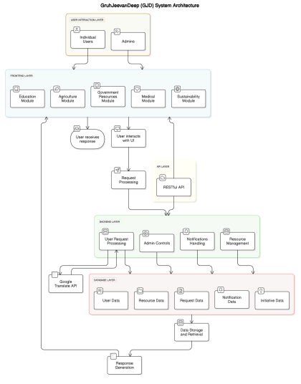
4.3 UML DESIGN
Unified Modeling Language (UML) is used to represent the structure and behavior of the Baby Monitoring System for Smart Cradle. The following diagrams help in visualizing the components and their interactions within the system.
4.3.1 CLASS DIAGRAM
- The class diagram represents the main components and their relationships within the Baby Monitoring System. It includes the following classes:
● NodeMCU: Represents the main controller that processes sensor data
Attributes: temperatureValue, movementStatus
Methods: readSensors(), processData(), displayStatus(), triggerAlert()
● GyroSensor: Detects cradle movement
Method: detectMovement()
● TemperatureSensor: Measures environmental temperature
Method: measureTemperature()
● LCD: Displays system status
Method: showStatus()
● Buzzer: Generates alert signals
Methods: activate(), deactivate()
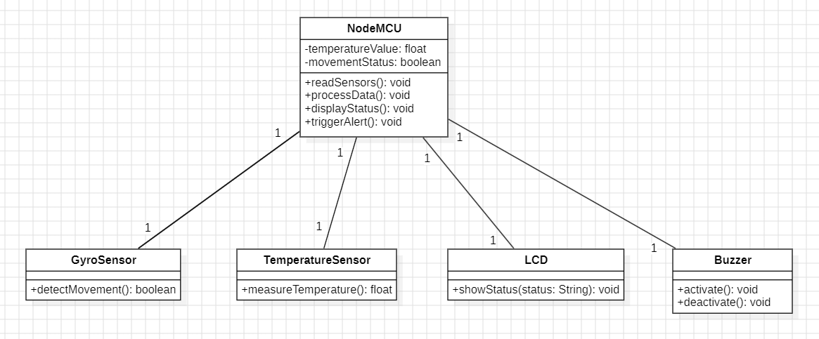
Fig 4.3.1: Class diagram
In software engineering, a class diagram in the Unified Modeling Language (UML) is a type of static structure diagram that describes the structure of a system by showing the system's classes, their attributes, operations (or methods), and the relationships among the classes. It explains which class contains information.
4.3.2 USE CASE DIAGRAM
- The use case diagram shows the interaction between the caregiver and the smart cradle system. The main use cases include:
● Monitor Baby: Caregiver observes system status through LCD
● View Temperature: Displays real-time temperature data
● Detect Motion: System monitors cradle movement
● Receive Alert: Caregiver is alerted during abnormal conditions
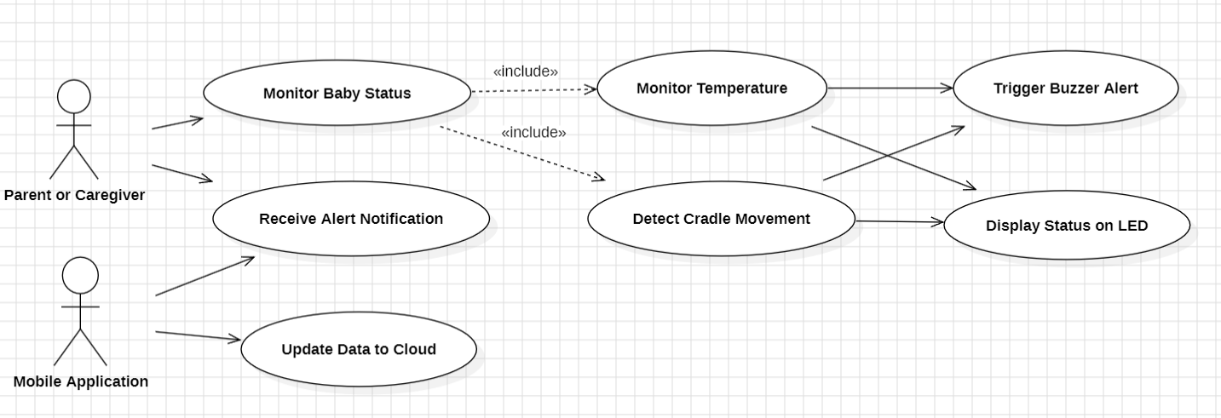
Fig 4.3.2 : Use Case Diagram
A use case diagram in the Unified Modeling Language (UML) is a type of behavioral diagram defined by and created from a Use-case analysis. Its purpose is to present a graphical overview of the functionality provided by a system in terms of actors, their goals (represented as use cases), and any dependencies between those use cases. The main purpose of a use case diagram is to show what system functions are performed for which actor. Roles of the actors in the system can be depicted.
4.3.3 COMPONENT DIAGRAM
This diagram represents the high-level components of the Baby Monitoring System and their interactions. The system is divided into the following components:
● Sensor Module: Includes gyro sensor and temperature sensor for data collection
● Processing Unit: NodeMCU processes the sensor data
● Display Module: LCD shows real-time system information
● Alert Module: Buzzer generates alerts during abnormal conditions
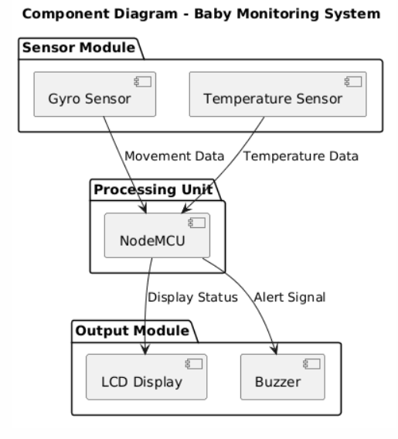
Fig 4.3.3: component diagram
4.3.4 SEQUENCE DIAGRAM
The sequence diagram shows the flow of interactions between system components over time. The sequence of operations is as follows:
● GyroSensor sends movement data to NodeMCU
● TemperatureSensor sends temperature data to NodeMCU
● NodeMCU processes the received data
● NodeMCU sends status to LCD for display
● If abnormal condition is detected, NodeMCU activates the buzzer
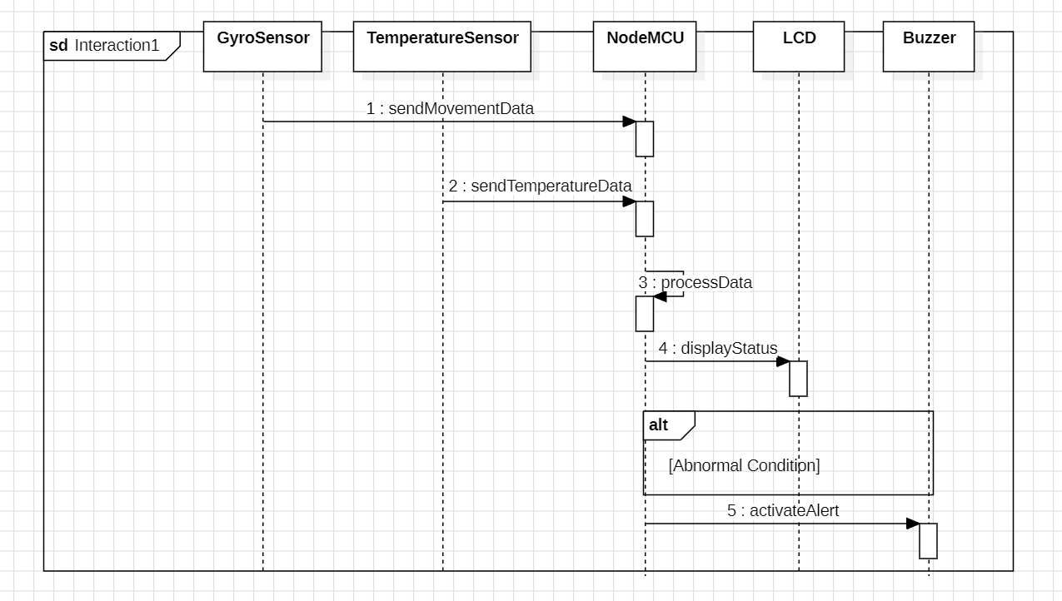
Fig 4.3.5: Sequence Diagram
4.3.5 ACTIVITY DIAGRAM
This diagram shows the flow of activities in the Baby Monitoring System. The steps include:
● Start system
● Read sensor data
● Process data
● Check condition
● If normal → display status
● If abnormal → activate buzzer
● Repeat monitoring
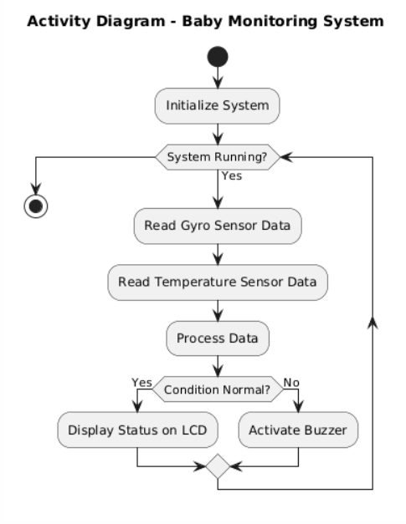
Fig 4.3.6: Activity Diagram
4.4 Technology Description
The Baby Monitoring System for Smart Cradle uses embedded system technologies to ensure efficient, reliable, and real-time monitoring of the baby’s environment and cradle movement.
● Microcontroller: NodeMCU is used as the main processing unit for controlling the system and handling sensor data.
●Sensors:
○ Gyro Sensor is used to detect cradle movement and identify abnormal motion.
○ Temperature Sensor is used to measure the surrounding temperature continuously.
● Display Unit: LCD Display is used to show real-time information such as temperature and system status.
● Alert System: Buzzer is used to generate audio alerts when unsafe conditions are detected.
● Programming Platform: Arduino IDE is used for writing, compiling, and uploading the embedded code to the NodeMCU.
● Programming Language: Embedded C/C++ is used for implementing system logic and controlling hardware components.
● Power Supply: A stable power source is required to operate the microcontroller and connected components efficiently.
5. IMPLEMENTATION
The implementation phase focuses on developing the Baby Monitoring System for Smart Cradle based on the design specifications. This involves integrating hardware components such as sensors, microcontroller, display unit, and alert system to ensure proper functioning of the system.
The following steps outline the implementation process:
●Hardware Integration:
All components including NodeMCU, gyro sensor, temperature sensor, LCD display, and buzzer are connected using appropriate wiring. Proper pin configuration is ensured for accurate data transmission.
●Sensor Interfacing:
The gyro sensor and temperature sensor are interfaced with the NodeMCU to collect real-time data. The sensors continuously send movement and temperature readings to the microcontroller.
●Programming:
The system is programmed using Embedded C/C++ in Arduino IDE. The code is written to read sensor data, process it, compare it with threshold values, and control output devices accordingly.
●Display Integration:
The LCD display is connected to the NodeMCU to show real-time information such as temperature and system status.
●Alert Mechanism:
The buzzer is programmed to activate when abnormal conditions such as excessive movement or high temperature are detected.
●Testing and Debugging:
The system is tested to ensure all components work correctly. Errors are identified and corrected to improve system performance.

5.2 MODULES:
The Baby Monitoring System for Smart Cradle is divided into several modules, each responsible for specific functions. These modules are designed to work together in coordination to ensure continuous monitoring of the baby’s environment and to provide timely alerts to caregivers. The modular design improves system reliability, simplifies implementation, and makes the system easy to maintain.
● Sensor Module
The Sensor Module is responsible for collecting real-time data from the environment and the cradle. It consists of a gyro sensor and a temperature sensor.
The gyro sensor detects cradle movement and helps in identifying abnormal or excessive motion, which may indicate discomfort or unsafe conditions for the baby. The temperature sensor continuously measures the surrounding temperature to ensure that the environment remains safe and comfortable.
This module plays a crucial role as it provides the input data required for further processing. Accurate and continuous sensing is essential for the proper functioning of the entire system.
● Processing Module
The Processing Module is the core of the system and is implemented using the NodeMCU microcontroller. It receives data from the sensor module and processes it based on predefined conditions.
The microcontroller continuously reads sensor values and compares them with threshold limits. Based on this comparison, it determines whether the system is operating under normal or abnormal conditions.
This module is responsible for decision-making and controlling the output modules such as the display and alert systems. It ensures that the system responds quickly and accurately to changes in sensor data.
● Display Module
The Display Module consists of an LCD display used to present real-time information to the caregiver. It displays important data such as temperature values and movement status of the cradle.
This module provides a user-friendly interface for monitoring the system without requiring any technical knowledge. It helps caregivers easily understand the current condition of the baby and the environment.
The display is continuously updated to reflect the latest sensor readings, ensuring that the user always has access to current information.
● Alert Module
The Alert Module is responsible for notifying the caregiver when unsafe conditions are detected. It consists of a buzzer that generates an audio alert.
When the processing module detects abnormal movement or temperature beyond safe limits, it sends a signal to the buzzer to activate. This immediate alert ensures that caregivers can respond quickly to any potential risk.
This module enhances the safety of the system by providing real-time warning signals without requiring constant manual monitoring.
● Control Module
The Control Module manages the overall operation of the system. It ensures that all modules work together in a synchronized manner.
It controls the continuous execution of the system by managing the flow of data between sensors, processing unit, and output devices. It also ensures that the system runs in a loop for real-time monitoring.
This module is responsible for maintaining system stability, ensuring efficient operation, and coordinating all activities within the smart cradle system.
5.3 EXECUTABLE CODE
#include <Wire.h>
#include <LiquidCrystal_I2C.h>

// LCD setup (I2C address 0x27, 16x2 display)
LiquidCrystal_I2C lcd(0x27, 16, 2);

// Pin definitions
int gyroPin = A0; // Gyro sensor analog pin
int tempPin = A1; // Temperature sensor analog pin
int buzzerPin = D5; // Buzzer pin

// Variables
int movementValue = 0;
float temperature = 0;

// Threshold values
int movementThreshold = 500;
float tempThreshold = 35.0;

void setup() {
Serial.begin(9600);

pinMode(buzzerPin, OUTPUT);

lcd.begin();
lcd.backlight();

lcd.setCursor(0, 0);
lcd.print("Smart Cradle");
delay(2000);
lcd.clear();
}

void loop() {

// Read gyro sensor (movement)
movementValue = analogRead(gyroPin);

// Read temperature sensor (convert to Celsius)
int tempRaw = analogRead(tempPin);
temperature = (tempRaw * 5.0 * 100.0) / 1024.0;

// Display values on LCD
lcd.setCursor(0, 0);
lcd.print("Temp:");
lcd.print(temperature);
lcd.print(" C ");

lcd.setCursor(0, 1);
lcd.print("Move:");
lcd.print(movementValue);
lcd.print(" ");

// Check abnormal conditions
if (movementValue > movementThreshold || temperature > tempThreshold) {
digitalWrite(buzzerPin, HIGH); // Turn ON buzzer
} else {
digitalWrite(buzzerPin, LOW); // Turn OFF buzzer
}

// Serial Monitor (for debugging)
Serial.print("Temp: ");
Serial.print(temperature);
Serial.print(" | Move: ");
Serial.println(movementValue);

delay(1000); // 1 second delay
}For all code and files Reference : https://github.com/

6. TESTING
6.1 TESTING DEFINITION:
The purpose of testing is to identify errors and ensure that the Baby Monitoring System for Smart Cradle works correctly under all conditions. Testing is the process of verifying that each component of the system performs its intended function and that the overall system meets the required specifications.
It provides a way to check the functionality of sensors, microcontroller, display unit, and alert system. Testing ensures that the system responds accurately to real-time conditions and does not fail during operation. Different types of testing are performed to validate system performance and reliability.
Unit Testing
Unit testing focuses on testing individual components of the system independently to ensure that each part works correctly before integration.
The key components tested include:
● Gyro Sensor: Testing whether the sensor correctly detects cradle movement and identifies abnormal motion.
● Temperature Sensor: Verifying accurate measurement of environmental temperature.
● LCD Display: Ensuring that the display shows correct and clear output.
● Buzzer: Checking whether the buzzer activates properly during abnormal conditions.
Field testing is performed by providing different inputs to each component and observing the output.
Test Objectives
●All sensors must provide accurate readings
● LCD should display correct real-time values
● Buzzer should activate immediately during abnormal conditions
● System should respond without delay
Features to be Tested
● Verify that sensor readings are within expected range
● Ensure proper communication between components
● Check system response for different input conditions
● Validate continuous operation without failure

Integration Testing
Integration testing is performed by combining all components of the system to ensure they work together properly.
In this phase, sensor data is sent to the NodeMCU, processed, and then displayed on the LCD. The buzzer is triggered when abnormal conditions are detected. The goal is to verify that all modules interact correctly without errors.
Acceptance Testing
Acceptance testing is conducted to verify that the system meets user requirements. The system is tested in real-time conditions to ensure that it performs as expected and provides reliable monitoring.
This testing confirms that the system is suitable for practical use and meets safety requirements.
Test Results:
All the test cases were executed successfully. The system was able to detect motion and temperature accurately, display correct values, and generate alerts during abnormal conditions. No major defects were observed during testing.
Outcomes Possible:
Pass: The system performs the expected operation correctly under given conditions.
Fail: The system does not produce the expected output and requires correction.
Error: Unexpected behavior occurs due to system or hardware issues.
Skipped: The test case is not executed due to specific conditions or constraints.
6.2 Test Cases
6.2.1 General Functionality
Test Case ID | Description | Expected Result
TC-SC-001 | Power ON system | System initializes successfully
TC-SC-002 | Sensor data reading | Sensor values are read correctly
TC-SC-003 | LCD display check | LCD displays temperature and movement
TC-SC-004 | Normal condition | No alert, system works normally
TC-SC-005 | Continuous monitoring | System runs continuously without interruption

6.2.2 Sensor Module
Test Case ID | Description | Expected Result
TC-SEN-001 | Gyro sensor movement detection | Detects cradle movement correctly
TC-SEN-002 | Temperature sensor reading | Displays accurate temperature values
TC-SEN-003 | Sensor data transmission | Data is sent to NodeMCU without delay

6.2.3 Processing Module
Test Case ID | Description | Expected Result
TC-PRO-001 | Data processing | NodeMCU processes sensor data correctly
TC-PRO-002 | Threshold comparison | System compares values with limits
TC-PRO-003 | Decision making | System identifies normal/abnormal condition

6.2.4 Display Module
Test Case ID | Description | Expected Result
TC-DIS-001 | LCD initialization | LCD starts properly
TC-DIS-002 | Display temperature | Correct temperature shown
TC-DIS-003 | Display movement | Movement status displayed correctly

6.2.5 Alert Module
Test Case ID | Description | Expected Result
TC-ALT-001 | Normal condition | Buzzer remains OFF
TC-ALT-002 | Abnormal movement | Buzzer turns ON
TC-ALT-003 | High temperature | Buzzer activates immediately

7. RESULTS
- After running the program we can see the following results


Figure-7.1.1 Home page

Figure-7.1.2 Language Translation

Figure-7.2.1 Agriculture

Figure-7.2.2 Waste Decomposer -Agriculture

Figure-7.3.1 Policies
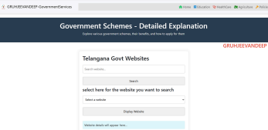
Figure-7.3.2 Search Policies

8. CONCLUSION
The Baby Monitoring System for Smart Cradle is designed to improve infant safety by providing continuous monitoring of cradle movement and environmental temperature. The system successfully integrates sensors, a microcontroller, and output devices to create a reliable and efficient monitoring solution.
The implementation of this system demonstrates how embedded technology can be used to detect abnormal conditions and provide real-time alerts to caregivers. The use of a gyro sensor and temperature sensor ensures accurate monitoring, while the LCD display and buzzer enhance user awareness and response.
The developed system is cost-effective, easy to use, and suitable for home environments. It reduces the need for constant manual supervision and ensures timely action during unsafe conditions. Overall, this project provides a practical solution for enhancing infant safety and comfort through simple and effective technology.

9. FUTURE SCOPE
While the Baby Monitoring System for Smart Cradle provides an effective solution for infant safety, there are several areas for future enhancement:
● IoT Integration:
In the future, the system can be connected to IoT platforms to enable remote monitoring through mobile applications. Caregivers can receive alerts and monitor the baby from anywhere.
● Mobile Application Support:
A dedicated mobile application can be developed to display real-time data, notifications, and system status, making monitoring more convenient.
● Additional Sensors:
The system can be enhanced by adding more sensors such as sound sensors, humidity sensors, or heartbeat sensors to provide more comprehensive monitoring.
● Camera Integration:
A camera module can be added to enable live video monitoring of the baby along with sensor-based alerts.
● Data Logging and Analysis:
The system can store sensor data for analysis, helping in understanding patterns related to baby movement and environmental conditions.
By implementing these enhancements, the system can become more advanced, intelligent, and user-friendly, further improving infant safety and caregiver convenience.

10. REFERENCES
● Arduino Official Documentation – https://www.arduino.cc
● NodeMCU (ESP8266) Documentation – https://nodemcu.readthedocs.io
● Temperature Sensor Datasheet (e.g., LM35/DHT11) – Manufacturer Datasheets
● Gyro Sensor Documentation (e.g., MPU6050) – Sensor Datasheets
● LiquidCrystal LCD Library Documentation – Arduino Library Reference
● Embedded Systems and IoT Concepts – Standard Textbooks and Online Resources
● Wikipedia: General information on sensors, microcontrollers, and IoT https://www.wikipedia.org

